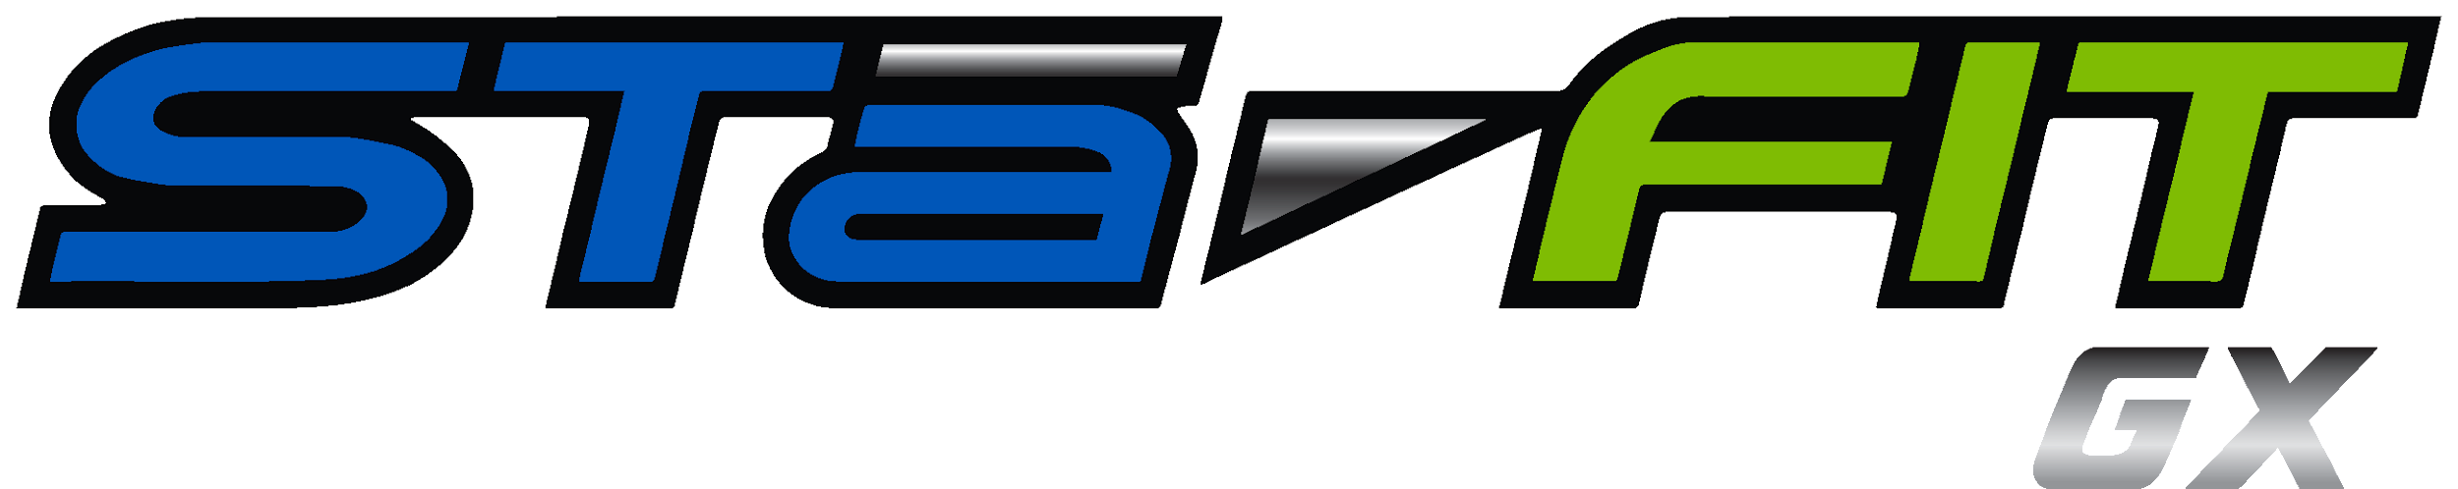

Classes Marked with * are located in the Pedal/Pose Studio. Classes Marked with (Z) offered via Zoom meeting code 779-511-4621
 | Monday | Tuesday | Wednesday | Thursday | Friday | Saturday
5:15 am | Body Pump - Jill P | Cycle* - Marsha | Body Pump Jill P | GRIT (Z) - Marj 5:00  Cycle*Abbi/ Amy | Body Pump Jill P
7:30 |  |  |  |  |  | Rotation Marsha
8:00 am |  | Body Pump Melissa |  |  | Silver Sneakers Becky
8:30am Pool | SS Aqua Fit Mary |  | SS Aqua Mary |  | SS Aqua Fit Mary | Aqua Fit Mary
8:30am | Body Balance Yoga Lori  Cycle* Jill D | Silver Sneakers* Becky | Body Balance Yoga Lori  Silver Sneakers* Becky | Body Pump Trish |  | 8:15 Body Pump  Marsha
9:00 am |  | SS Yoga Janet |  | SS Yoga*Janet | Cardio D/Zumba Becky
9:30 am  9:45 am ** | Body Pump- Jill |  | Body Strength*Janet  Silver Sneakers Becky**
10:00 am |  | Silver Sneakers Becky |  | Cardio Dance Becky | SS Yoga Janet
10:35 am |  |  | SS Yoga Becky
11:35 am | Silver Sneakers Sally
4:30pm  4:45 pm GRIT only | Body Strength-Amy  LM Grit* Marsha/Marj | Barre - Amy | Yoga- Amy*  Zumba - Kim | Cycle* - Marj
5:30pm | Body Pump Marsha  Cycle* Amy | Zumba - Kim  Body Pump (Z)* - Marj | Body Pump Marsha  Core (Z)* - Marj* | Body Balance *- Marsha  Body Strength -(Z) Marj
5:30 pm Pool | Master Swim Beth | Aqua Mary
GROUP  FITNESS CLASS DESCRIPTIONS | - BODYPUMP™--The original LES MILLS™ barbell class, will sculpt, tone and strengthen your entire body, fast!Using light to moderate weights with lots of repetitions.  - LES MILLS GRIT™ Cardio is a 30-minute high-intensity interval training (HIIT) workout that improves cardiovascular fitness, increases speed and maximizes calorie burn. This workout uses a variety of body weight exercises and provides the challenge and intensity you need to get results fast. LES MILLS GRIT Cardio takes HIIT and combines it with powerful music and inspirational coaches who will be down on the floor with you, motivating you to go harder to get fit, fast.  - CYCLE 360 - A high energy form focused cycle class open to beginner or avid cyclists. You will get an amazing interval cardio workout while strengthening your glutes, hams, and more! During the workout you will grab some hand weights for a total body workout.  - SPIN - The same great workout as cycle 360 but you will remain on the bike the entire time  - Butts and Guts is a special focus class just for your lower body! Sculpt, shape, and strengthen your abdominal, buttock, and thigh muscle groups. This class will strengthen and tone all your core muscles, working on the back, butt and thighs in particular. By combining elements of Pilates, strength training, stability ball, resistance bands and more, this class is sure to get those ab and tush muscles firmed up and well toned. Designed for all fitness levels  - SilverSneakers - focuses on strengthening muscles and increasing range of movement for daily life activities. Participants can use hand-held weights, elastic tubing with handles and a SilverSneakers ball. Often a chair is used for seated exercises or standing support.  - SilverSneakers Splash - provides a fun environment using a splash-board to increase movement and intensity options during shallow-water exercises. This class is suitable for all skill levels, and even safe for those who don’t swim.  - Zumba - Zumba is a fitness program that combines Latin and international music with dance moves. Zumba routines incorporate interval training — alternating fast and slow rhythms — to help improve cardiovascular fitness  - Latin Dance - Get ready for an interval style dance party. You will burn a lot of calories using Latin inspired dance moves. It is so much fun you will forget you are exercising.  - Master Swim - Masters is designed for those who swim with the benefit of individual coaching. Each workout is designed to be fun and exciting as well as improve your technique.

